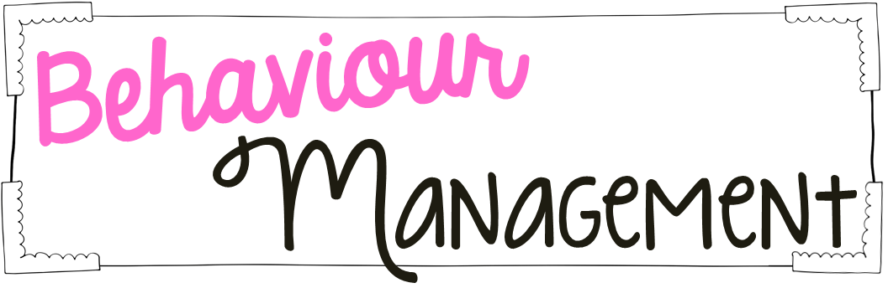
- Non-verbal warning
- Verbal warning
- Re-location
- Always treat others the way you want to be treated.

